CONFIDENTIAL CS/OCT 2026/MAT133

UNIVERSITI TEKNOLOGI MARA FINAL EXAMINATION

COURSE
COURSE CODE
EXAMINATION TIME
PRE CALCULUS
MAT133 OCTOBER 2026
2 HOURS

INSTRUCTIONS TO CANDIDATES

- This question paper consists of 5 questions.

- Answer ALL questions in the Answer Booklet. Start each answer on a new page.

- Do not bring any material into the examination room unless permission is given by the invigilator .
- Please check to make sure that this examination pack consists of: i) the Question Paper
  - a one - page Append ix 1
  - an Answer Booklet - provided by the Faculty
  - a graph paper - provided by the Faculty

- Answer ALL questions in English.

/

DO NOT TURN THIS PAGE UNTIL YOU ARE TOLD TO DO SO

This examination paper consists of 7 printed pages

QUESTION 1
a) Write the solution of -3x - 4 < -4 in interval notation and on a number line.
(3 marks)
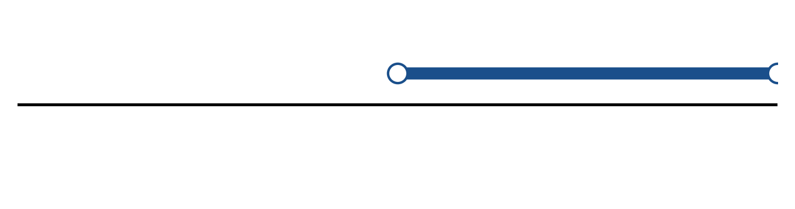
Figure: solution set.
b) Solve the inequality |4x - 5| < 4. Express the answer in interval notation and on a number line.
(5 marks)
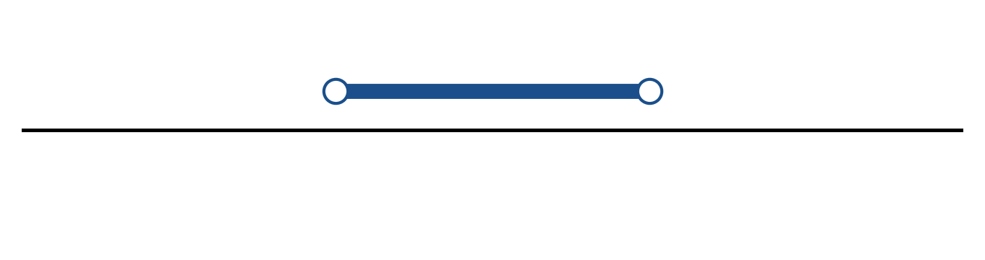
Figure: solution on a number line.
c) Sketch y = -2|x - 2| - 5. State the vertex, the y-intercept and any x-intercepts.
(5 marks)
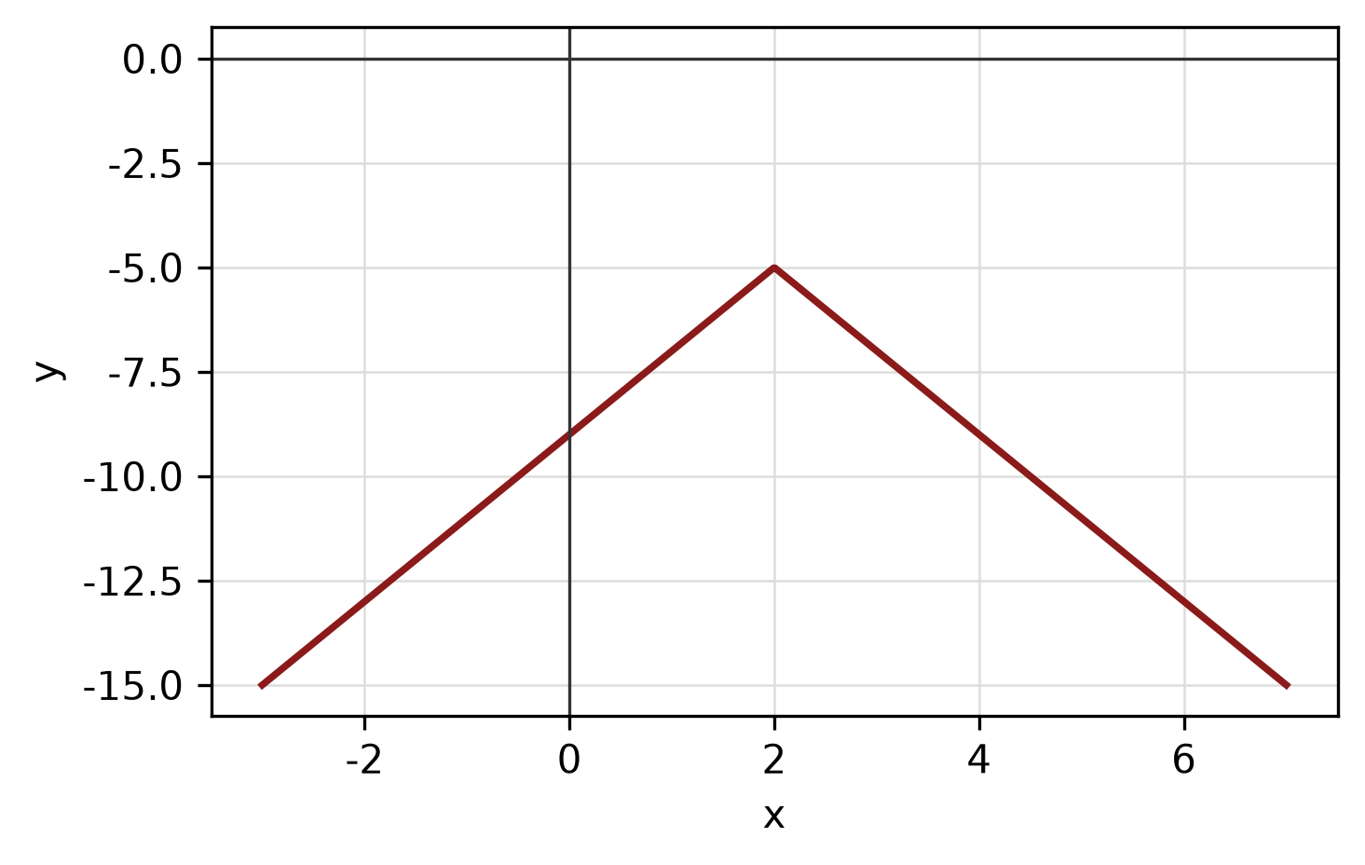
Figure: absolute-value graph.
QUESTION 2
a) Apply graph-transformation techniques to sketch y = 2(x + 5)² + 6. State the vertex and the y-intercept.
(5 marks)
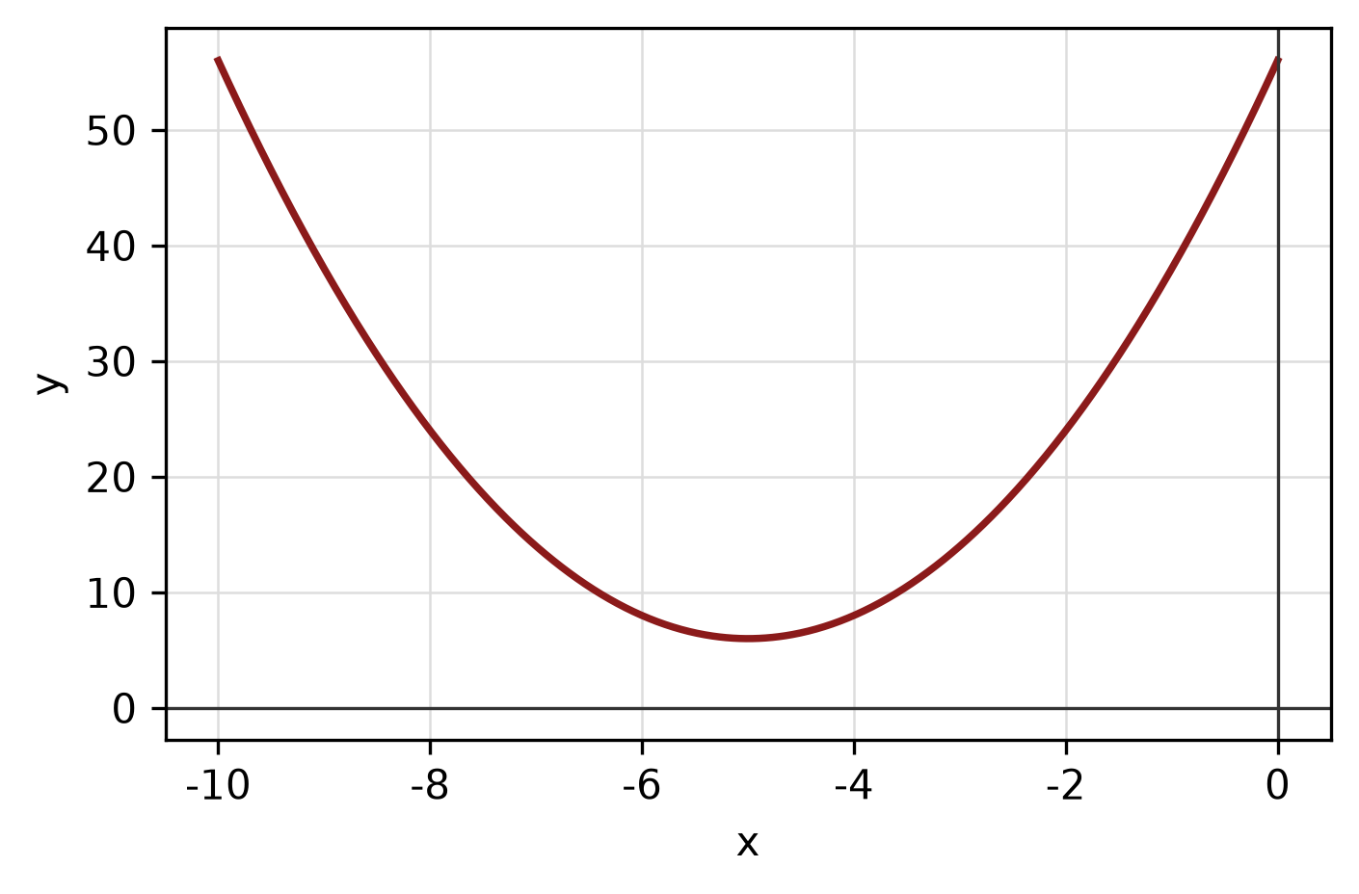
Figure: transformed graph.
b) Determine algebraically whether f(x) = x^5 - 3x^3 - 6x is even, odd or neither. State the symmetry of its graph.
(4 marks)
c) Write x² - 2x + y² + 10y - 10 = 0 in standard form. Hence state the centre and radius and sketch the circle.
(5 marks)
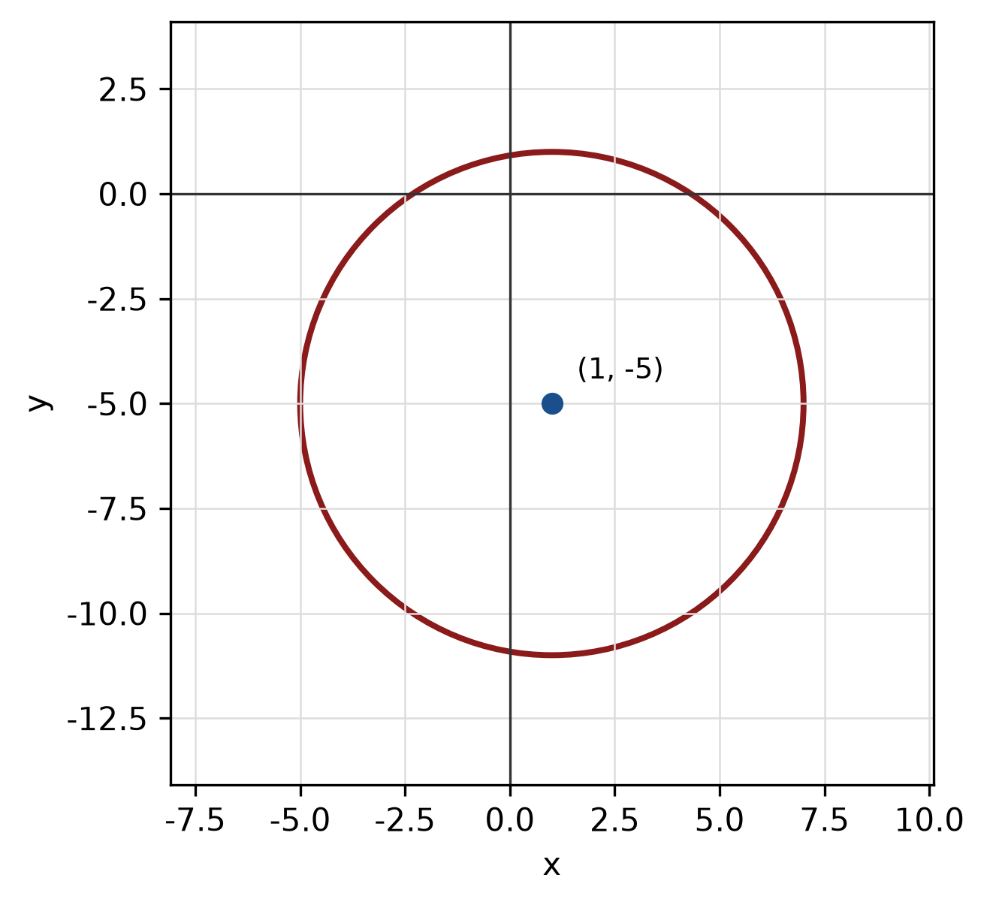
Figure: circle.
QUESTION 3
a) Given z₁ = -3 + 3i and z₂ = 1 - i, express z₁/z₂ in the form a + bi.
(5 marks)
b) Find the modulus and argument of z = 8 + 15i. Give the argument in degrees correct to one decimal place.
(5 marks)
c) Use synthetic division to divide f(x) = -3x^3 - 5x² + x + 3 by x + 4. State the quotient and remainder.
(5 marks)
QUESTION 4
a) Write a system of inequalities that describes the shaded triangular region with vertices (0, 0), (3, 0) and (0, 8).
(5 marks)
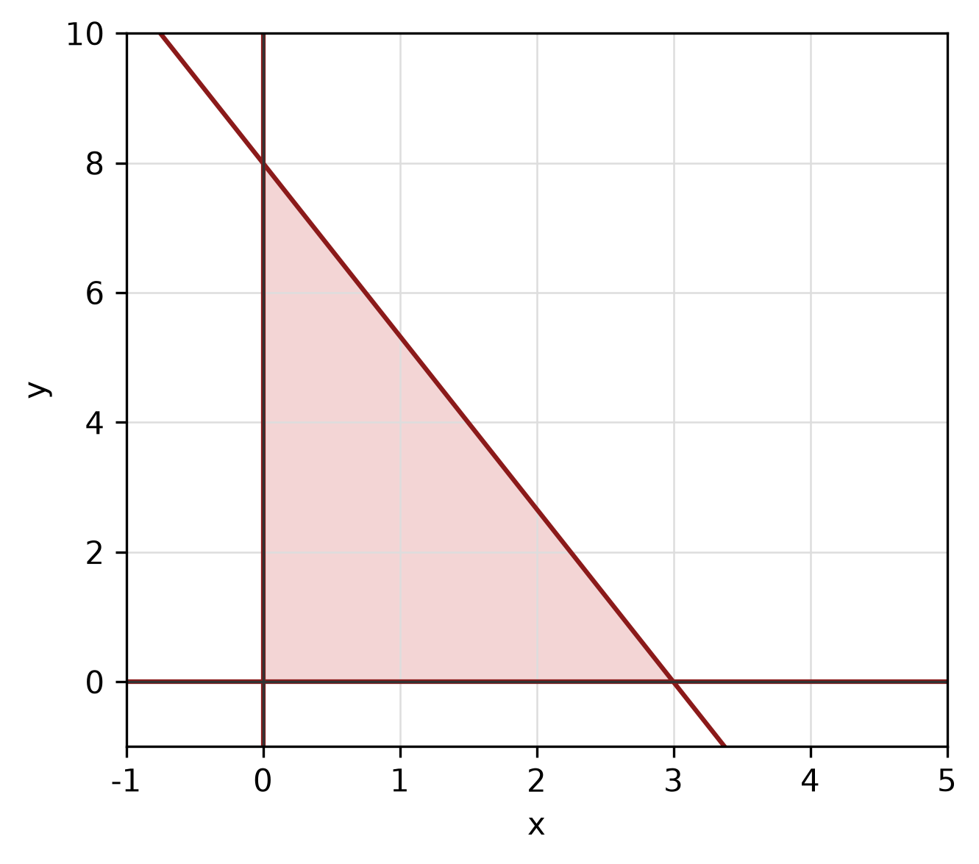
Figure: shaded triangular region.
b) Solve the simultaneous equations
y = x² - 4
y = -6x - 12.
(5 marks)
c) Write y = x²/4 + 3x/2 + 1/4 in standard form. Hence state the vertex, focus and directrix, and sketch the parabola.
(5 marks)
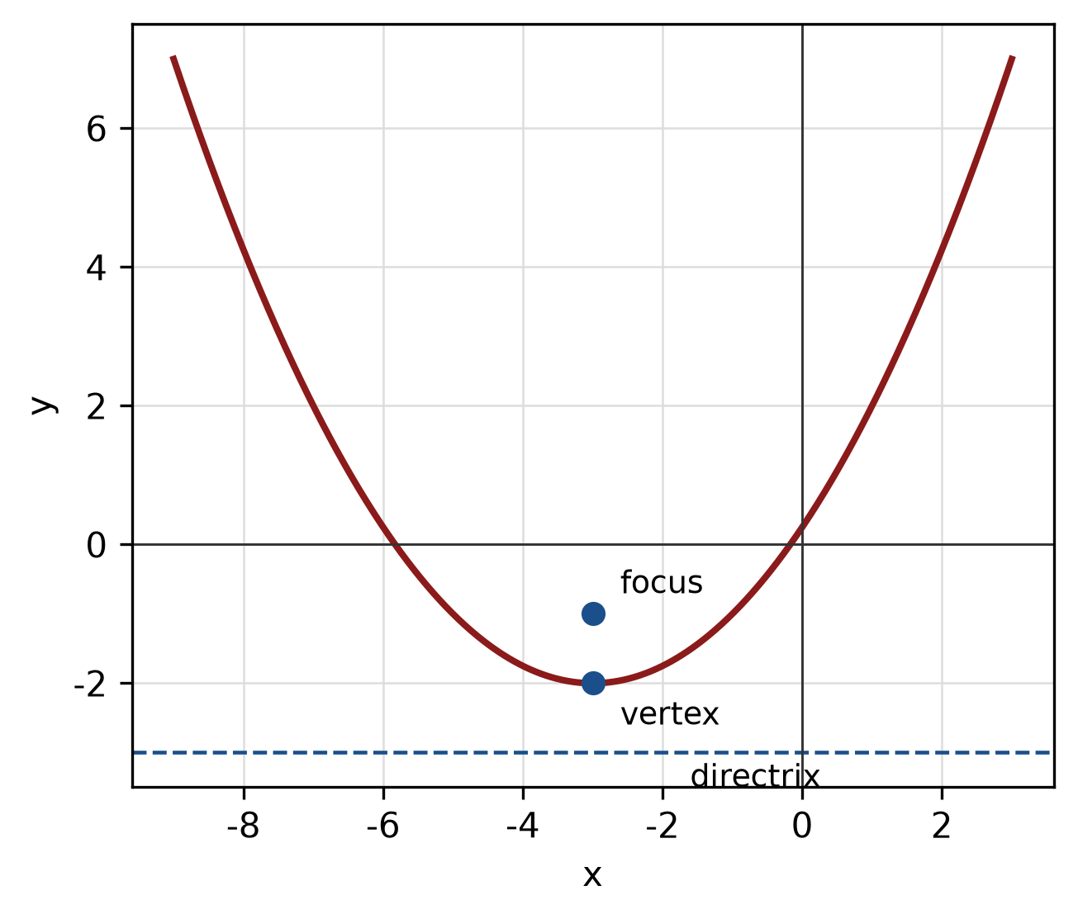
Figure: parabola.
QUESTION 5
a) Given sin A = 5/13 where A is in quadrant II and cos B = 12/13 where B is in quadrant IV, find sin 2A and cos(A + B).
(5 marks)
b) A circle has radius 13 cm. Find the length of the arc subtended by a central angle of 150°.
(4 marks)
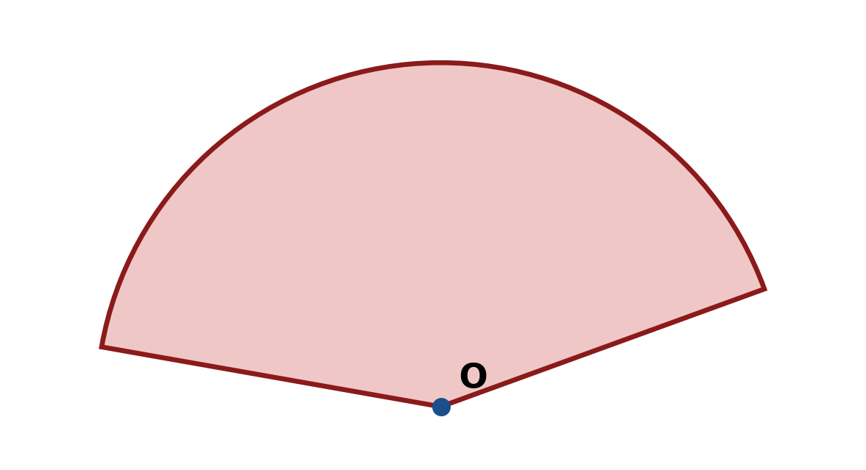
Figure: arc and sector.
c) In triangle ABC, A = 45°, B = 60° and a = 13 cm. Use the sine rule to find b.
(4 marks)
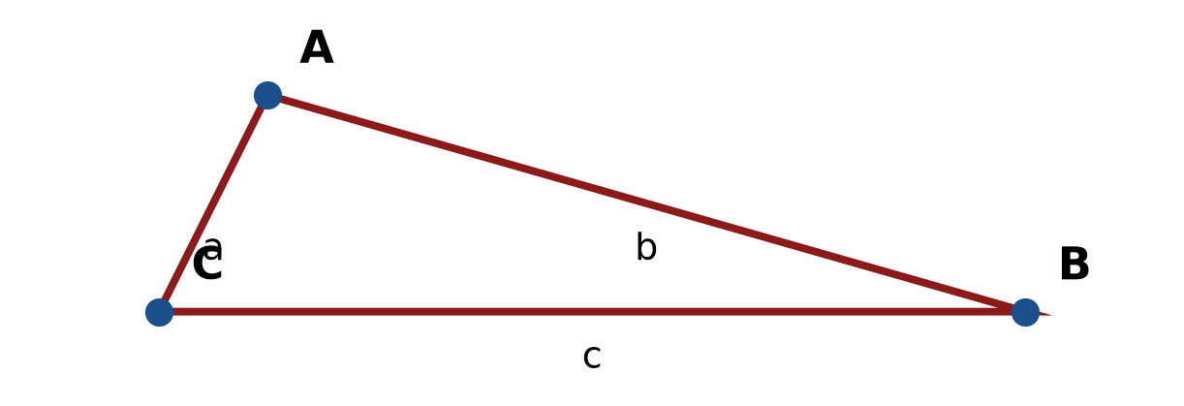
Figure: triangle ABC.
END OF QUESTION PAPER

APPENDIX 1
Formula sheet (as supplied with the paper).
sin² A + cos² A = 1 | tan² A + 1 = sec² A
sin(A + B) = sin A cos B + cos A sin B | tan 2A = 2 tan A / (1 − tan² A)
cos(A + B) = cos A cos B − sin A sin B | Arc length, s = rθ
tan(A − B) = (tan A − tan B) / (1 + tan A tan B) | Area of sector = ½r²θ
cos 2A = cos² A − sin² A | a / sin A = b / sin B = c / sin C
cos 2A = 1 − 2sin² A = 2cos² A − 1 | a² = b² + c² − 2bc cos A
sin 2A = 2 sin A cos A | Area of triangle = ½ab sin C

